**NOTE LEARNING PYTHON NECESSARY**

# Python fundamental

## String format function

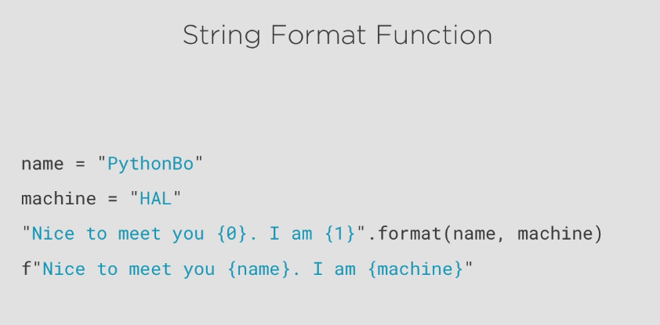

## Underscode(-) mean in python

_ has 3 main conventional uses in Python:

-To hold the result of the last executed expression(/statement) in an interactive interpreter session. This precedent was set by the standard CPython interpreter, and other interpreters have followed suit

-For translation lookup in i18n (see the gettext documentation for example), as in code like: raise forms.ValidationError(_("Please enter a correct username"))

-As a general purpose "throwaway" variable name to indicate that part of a function result is being deliberately ignored, as in code like: label, has_label, _ = text.partition(':')

The latter two purposes can conflict, so it is necessary to avoid using _ as a throwaway variable in any code block that also uses it for i18n translation (many folks prefer a double-underscore, __, as their throwaway variable for exactly this reason).